**Tāwhiri Warehouse Venue Information Document**

**To make a booking please contact the Tāwhiri team on tawhiriwarehousehire@tawhiri.nz**

**Venue Overview**

The Tāwhiri Warehouse is the new up and coming venue by Tāwhiri. The space used to be the old Capital Gymnastics building and is currently in development to turn the space around into a rehearsal and performance space.

**Location and Access:**

The venue is located at 11 Hutchison Road, at the rear of the Te Whaea complex beside Circus Hub. Access is via Hutchison Road, with secondary access possible through the Hall Street carpark.

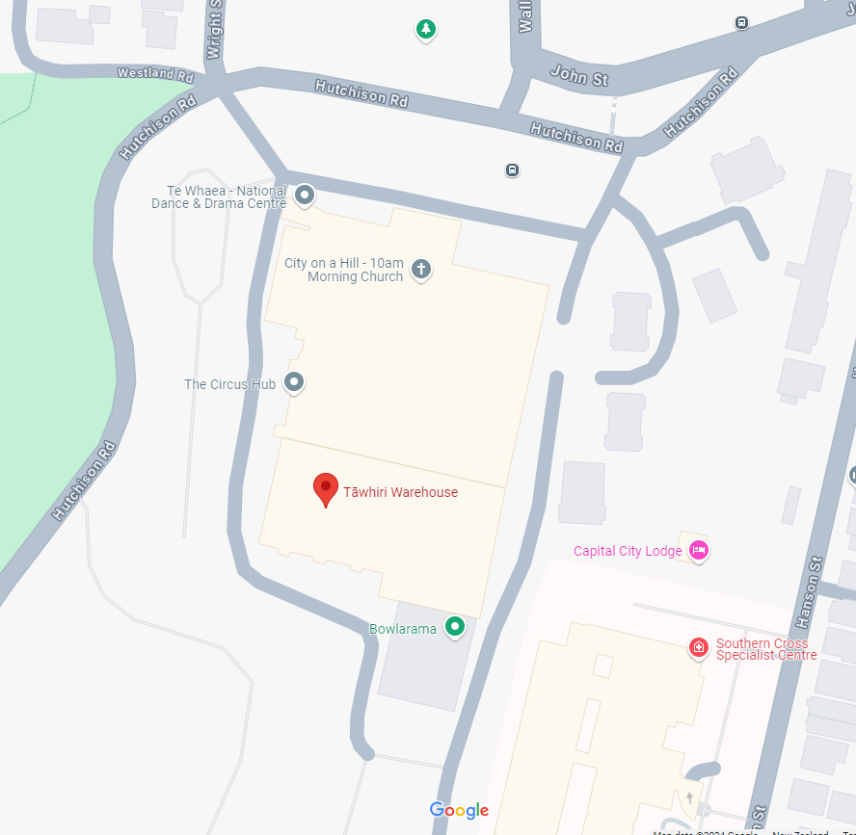

The venue has three sets of double doors and a larger roller door that facilitates loading and unloading of equipment directly onto the ground floor of the venue.

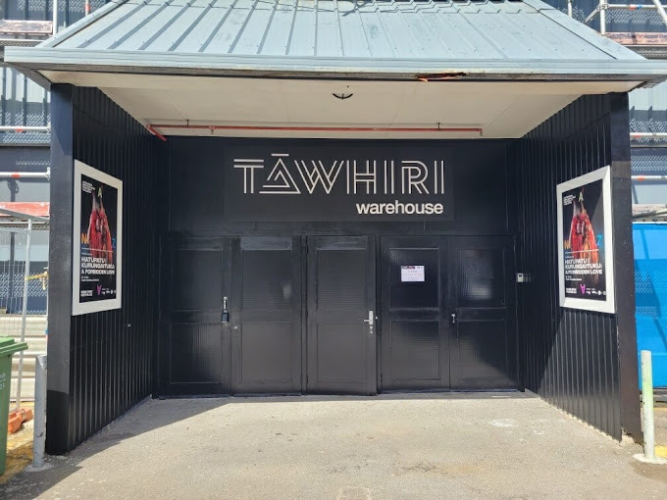

**Parking:**

There is over 200 shared parking for all users of the Te Whaea complex on a first in first served basis, with no reserving parks available.

**Critical Dimensions:**

38m long x 35m wide

9m height at centre apex and 6m height at outer walls

**Floor:**

The previously sprung floor has been lifted, and the floor surface is now down to bitumen and tongue and groove. Weight loadings are : 700kgsqm across the bitumen floor and 350kgsqm across timber tongue and groove floor.

As such, any set elements or other ground-based structures must be signed off by Tāwhiri’s Head of Technical Production prior to installation to ensure they satisfy load capacity limitations.

Forklifts, EWPs, and other vehicles can be driven on the bitumen part of the floor.

**Staffing:**

At the moment no staffing comes with the venue. We give you access to the building for you to self manage. If you require any staffing please chat to us about that.

**Facilities**

**Bathrooms:**

Located on the ground floor at the rear of the venue, consisting of 3 cubicle toilets, and 1 wheelchair accessible toilet.

**Kitchenette:**

There is a kitchenette located on the mezzanine above the bathrooms.

**Heating and cooling:**

There is currently no heating, cooling, or air movement system in this space.

**Wifi:**

Standard wifi is available in the venue. If you have specific requirements please to us further. You may be required to bring in anything specific yourself.

**Cleaning:**

The bathrooms are cleaned, and supplies restocked on a weekly basis. Should cleaning frequency need to increase during the Hire Period to meet increased demand please notify us.

**Rubbish:**

Weekly wheelie bin collection on Wednesday from the front door – please ensure the bin is outside and accessible for collection.

**Laundry:**  
We have 1 x washing machine, and 1 x drier located on the mezzanine floor. We also have a laundry basin and irons, ironing boards, and steamers for your use.

**Technical Infrastructure**

**Power:**

Main technical power via 200amp three phase powerlock outlet with numerous 10amp power outlets distributed throughout the building.

**Production Lighting:**

There is currently no production lighting in place in the venue, and if this is required you would need to hire this in. Our preferred lighting supplier is Illumination + Optics

**Sound:**

We have a D&B A series for the main PA, and a db Tech opera series for a small system available in the venue for an additional cost to the venue hire. If you require anything further, our preferred sound suppliers are Western Audio.

|  |  |  |  |
| --- | --- | --- | --- |
| **Equipment** | **Brand & Model** | **Quantity** | **Notes** |
| Console | Soundcraft EPM6 | 1 | 6 channel |
| Console | Yamaha DM3 | 1 | 8 channel |
| Console | Yamaha MG12 | 1 | 12 channel |
| Speakers | EV S-200 | 4 |  |
| Speakers | Db Tech Opera Series |  |  |
| Speakers | D&B A Series |  |  |
|  |  |  |  |

**Smoke/Haze:**

Smoke and haze is possible within the venue. Please talk to the Head of Technical and Production

**Rigging:**

We have a standard rigging set up that can be used. See attached documents for rigging plans.

Our in house rigging supplier is YooCrew.

Note all suspended loads require sign off by Tāwhiri before anything is hung,

**Softgoods:**

We have some push up drape kits, and larger draping to hang off truss which can be hired in addition to your venue hire. Talk to us to discuss your requirements.

**Dancefloor:**

We have the below dancefloor for hire. Get in contact if you’d like to hire any of this.

|  |  |  |  |
| --- | --- | --- | --- |
| **Colour** | **Quantity** | **Width (m)** | **Length (m)** |
| Black/Grey | 1 | 2 | 18.2 |
| Black/Grey | 1 | 2 | 12.3 |
| Black/Grey | 4 | 2 | 12.2 |
| Black/Grey | 1 | 2 | 11.4 |
| Black/Grey | 1 | 2 | 7 |
| Black/Grey | 1 | 2 | 5.5 |
| Black/Grey | 1 | 2 | 5.4 |
| Black/White | 3 | 2 | 20.8 |
| Black/White | 1 | 2 | 20.7 |
| Black/White | 2 | 2 | 17.9 |
| Black/White | 1 | 2 | 17.8 |
| Black/White | 1 | 2 | 17.7 |
| Black/White | 1 | 2 | 17.6 |
| Black/White | 2 | 2 | 8.1 |
| Black/White | 2 | 1 | 7.7 |
| Black/White | 2 | 2 | 3.8 |

**Preferred Supplier Contacts:**

*Illumination + Optics*

Morgan Whitfield

[Morgan@i-o.nz](mailto:Morgan@i-o.nz)

021 077 2530

*YooCrew*

Sam Johnston

[Sam@yoocrew.co.nz](mailto:Sam@yoocrew.co.nz)

027 28 28 437

*Western Audio*

Sebastian Hesp

[Sebastian@westernaudio.co.nz](mailto:Sebastian@westernaudio.co.nz)

021 105 3433

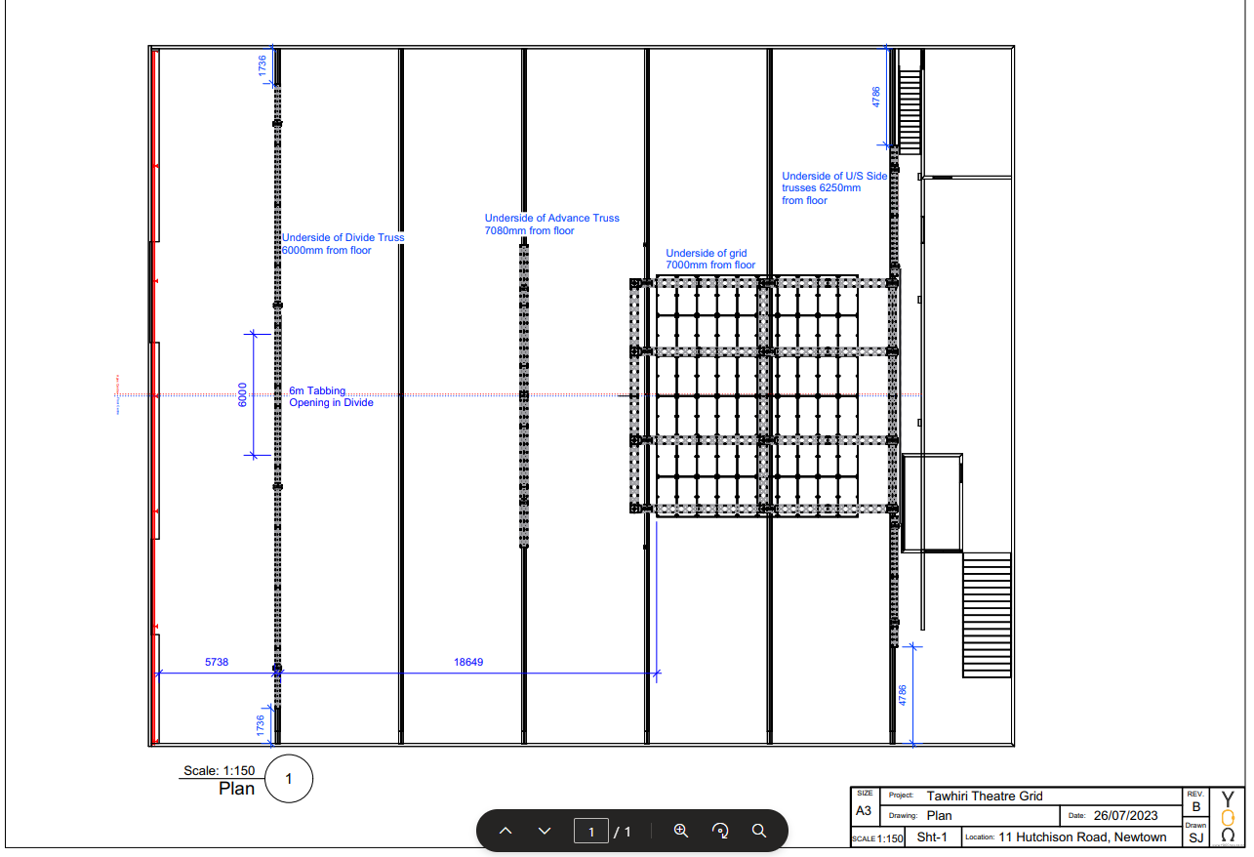**Rigging Plan:**

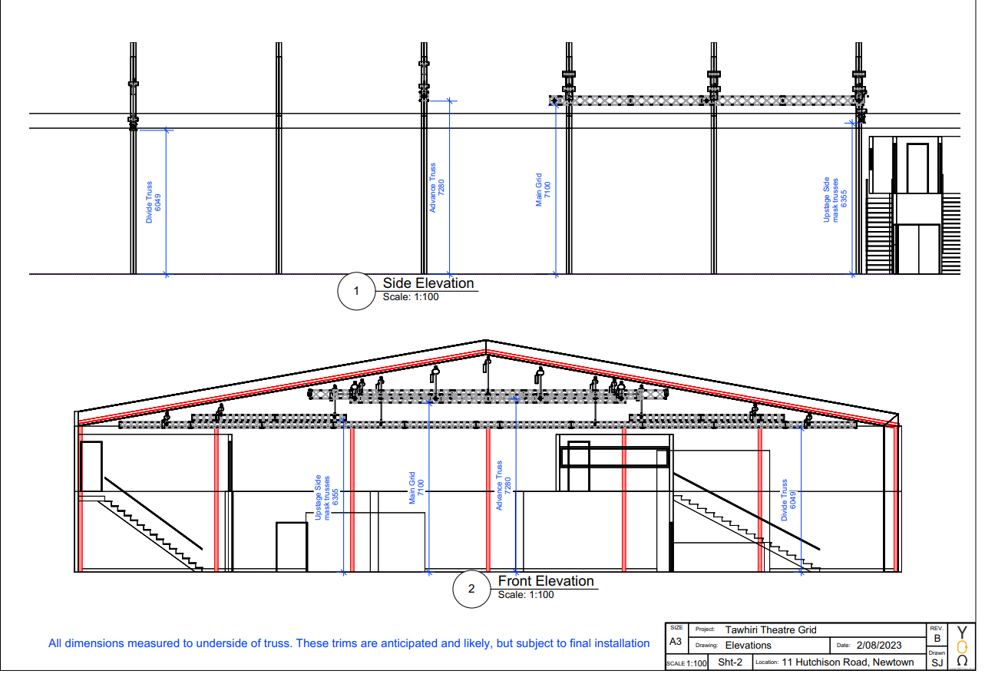**Rigging Elevations Plan:**